REQUIREMENT ANALYSIS
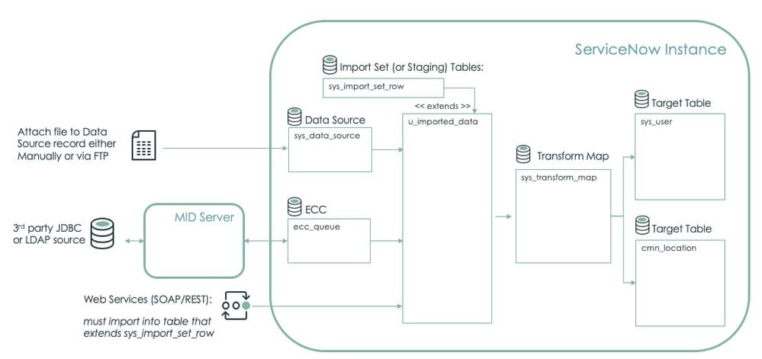

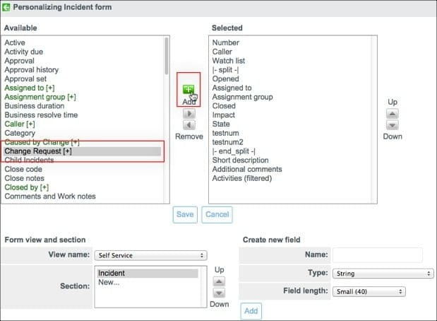

FUNCTIONAL REQUIREMENTS
Functional requirements describe the main operations and features that the system must perform.
- Data Import Functionality
The system should allow administrators to import user data from external files such as CSV or Excel into the ServiceNow platform using Import Sets.
- Data Storage in Tables
The imported data should be stored in appropriate ServiceNow tables such as the User table. The system must ensure that the data is stored correctly without duplication.
- Data Transformation
The system should transform the imported data using Transform Maps so that it can match the structure of ServiceNow tables.
- Relationship Mapping
The system should automatically establish relationships between records. For example, when a user is imported, the system should link that user to their department, manager, or other related records.
- Dot Walking Functionality
The system should use Dot Walking to automatically retrieve related information from linked tables. For example, when a user is selected in the incident form, the system automatically displays related fields like email, department, and manager.
- Auto-Fill Fields
When a user is selected in the “Assigned To” field in the Incident form, the system should automatically populate related details such as:
- Department
- Email
- Manager
- Incident Creation Support
The system should allow the IT team to create incidents and assign them to users whose information has been imported into the system.
NON-FUNCTIONAL REQUIREMENTS
Non-functional requirements describe how well the system should perform.
- High Data Accuracy
The system must ensure that imported data is accurate and consistent without data loss or duplication.
- Fast Processing Speed
The system should process and import large amounts of data quickly without causing delays.
- User-Friendly Interface
The interface should be easy to use so that administrators and IT staff can import data and manage records without difficulty.
- Reliability
The system should work continuously without errors and must be able to handle multiple data imports.
- Security
The system must ensure that sensitive user information such as email and department details are securely stored and accessed only by authorized users.
- Scalability
The system should be able to handle increasing data volume as the organization grows.

HARDWARE REQUIREMENTS
The hardware required to develop and use the system includes:
- Laptop or Desktop Computer for accessing the ServiceNow platform and managing data import tasks.
- Minimum 4 GB RAM recommended for smooth operation.
- Stable Internet Connection to access the cloud-based ServiceNow platform.
SOFTWARE REQUIREMENTS
The software tools required for the project include:
- Web Browser such as Google Chrome, Microsoft Edge, or Mozilla Firefox to access the ServiceNow platform.
- ServiceNow Platform for creating Import Sets, Transform Maps, and implementing Dot Walking.
- CSV or Excel File containing user data for importing into the system.
- Operating System such as Windows, macOS, or Linux.
SYSTEM USERS
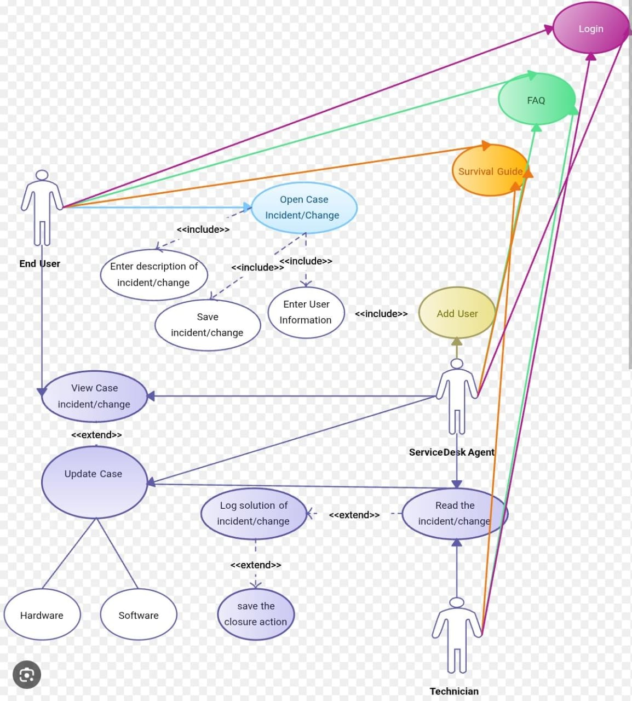
Different types of users interact with the system.
- System Administrator
The administrator manages the ServiceNow instance, configures Import Sets, creates Transform Maps, and ensures proper data import and relationship mapping.
- IT Support Team
The IT support team uses the system to create and manage incidents. They assign incidents to users and rely on the system to automatically fill related information.
- ServiceNow Users
These users are employees or staff members whose information is stored in the ServiceNow database. Their records are used for assigning incidents and managing organizational data.

